T-106.1227 Data Structures and Algorithms
Project Report (Solution Part)
Nan Chen
266035
08.04.2011
Table of Contents
1.Introduction 1
a)General description and aims (orientation, motivation, goals) 1
b)Justification of the library, exclusions if not feasible to evaluate all structures 1
2.Literature survey 1
a)General descriptions of the library 1
b)List of data structure and algorithms 2
c)Analytical results of the data structures and algorithms 2
d)Working environment 2
e)Evaluation methods (time and / or space) 3
3.Results 4
a)Empirical results of the algorithms & Comparison with the analytical results 4
4.Discussion 5
5.Time consumption 5
6.References 6

Introduction

General description and aims (orientation, motivation, goals)
The project is to create and test the efficiency in terms of time and memory usage of a small C-language library of generic data structures modified from the source code provided by the book <Data Structures and Algorithm Analysis in C (Second Edition, Mark Allen Weiss)>. This small library would not be a business-class comprehensive one, but for academic purposes, by creating it, going through and examining it, a student should obtain detailed knowledge and hands-on experience of general data structures thoroughly. And during the process of the project, student is supposed to form a systematic way of thinking in Data Structures and Algorithms with real implementation issues.

In addition, in case a sophisticated data structure is found to be particularly interesting and not existing in the library, the data structure in question from standard Java library (java.util, if the structure exists in) will be examined instead.

Justification of the library, exclusions if not feasible to evaluate all structures
So far, Linked List, AVL Tree and several sorting algorithms have been evaluated. They are chosen as Representatives of a branch of similar data structures.

Literature survey

General descriptions of the library

List of data structure and algorithms
Evaluated data structures are highlighted
Data structure | Operations
List
Linked List | MakeEmpty, IsEmpty, IsLast, Find, Delete, FindPrevious, Insert, DeleteList, Header, First, Advance, Retrieve
Linked List (cursor version) | Same as List
Stack (array version) | IsEmpty, IsFull, CreateStack, DisposeStack, MakeEmpty, Push, Top, Pop, TopAndPop
Stack (list version) | IsEmpty, CreateStack, DisposeStack, MakeEmpty, Push, Top, Pop
Queue | IsEmpty, IsFull, CreateQueue, DisposeQueue, MakeEmpty, Enqueue, Front, Dequeue, FrontAndDequeue
Tree
Tree | MakeEmpty, Find, FindMin, FindMax, Insert, Delete, Retrieve
AVL Tree | MakeEmpty, Find, FindMin, FindMax, Insert, Retrieve
Top-down Splay Tree | MakeEmpty, Find, FindMin, FindMax, Initialize, Insert, Remove, Retrieve
Determinstic Skip List | MakeEmpty, Find, FindMin, FindMax, Initialize, Insert, Remove, Retrieve
Top-down Red Black Tree | MakeEmpty, Find, FindMin, FindMax, Initialize, Insert, Remove, Retrieve, PrintTree
Treap | MakeEmpty, Find, FindMin, FindMax, Initialize, Insert, Remove, Retrieve
AA Tree | MakeEmpty, Find, FindMin, FindMax, Initialize, Insert, Remove, Retrieve
K-D Tree | RecursiveInsert, RecPrintRange
Hash Table
Hash Table(separate chaining) | InitializeTable, DestroyTable, Find, Insert, Retrieve
Hash Table (quadratic probing) | InitializeTable, DestroyTable, Find, Insert, Retrieve, Rehash
Heap
Binary Heap | Initialize, Destroy, MakeEmpty, Insert, DeleteMin, FindMin, IsEmpty, IsFull
Leftist Heap | Initialize, FindMin, IsEmpty, Merge, Insert, DeleteMin
Pairing Heap | Initialize, Destroy, MakeEmpty, Insert, DeleteMin, FindMin, DecreaseKey, IsEmpty, IsFull
Sorting
Sorting Algorithms | InsertionSort, Shellsort, Heapsort, Mergesort, Quicksort
Other
Disjoint Set | Initialize, SetUnion, Find

Analytical results of the data structures and algorithms

Working environment
ubuntu 10.10, gnu plot, gcc, eclipse, codeblocks, github.com, git scm

Evaluation methods (time and / or space)
Originally it was planned to use “clock_t clock(void)” method provided by c standard library, but it has been found on Linux(Ubuntu 10.10 32-bit) the minimal unit is 10 ms. Thus the accuracy of this approach would be poor unless large input size per test is used. The figure below illustrates the inaccuracy with small inputs
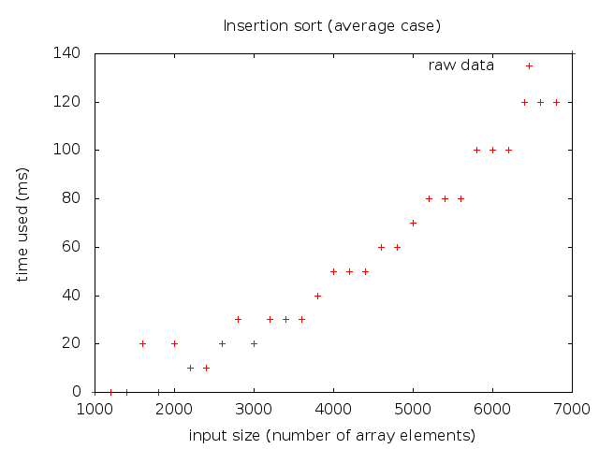

To have acceptable accuracy, the input size must be larger, time used must be longer, as below:
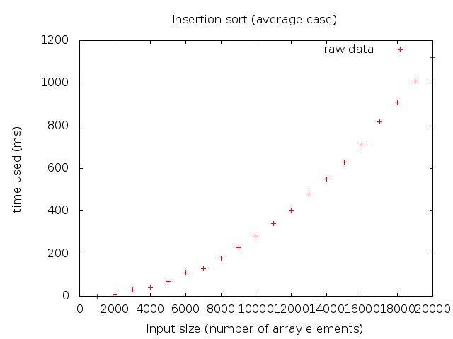

Therefore, In this project, for recording time/space consumption, I mainly use a method of “embedding code” to achieve fine-grained unit of time & space. On the other hand, the real time measurement (using “clock_t clock(void)”) is also supported by the measurement module.

Results

Empirical results of the algorithms

Operation | Empirical time | Time RSD | Analytical time | Empirical space | Space RSD | Analytical space
List
List_makeEmpty | Time(N) = 4.10 * N | 5.42% | O(N) | Space(N) = -7.96 * N | 1.17% | O(N)
List_isEmpty | Time(N) = 4.00 |  | O(1) | Space(N) = 4.00 |  | O(1)
List_isLast | Time(N) = 4.00 |  | O(1) | Space(N) = 8.00 |  | O(1)
List_find-(worst-case) | Time(N) = 2.05 * N | 5.14% | O(N) | Space(N) = 8.00 |  | O(1)
List_delete | Time(N) = 27.00 |  | O(1) | Space(N) = -8.00 |  | O(1)
List_findPrevious-(worst-case) | Time(N) = 10.00 |  | O(1) | Space(N) = 8.00 |  | O(1)
List_insert-(onto-first) | Time(N) = 14.00 |  | O(1) | Space(N) = 20.00 |  | O(1)
List_deleteList | Time(N) = 4.05 * N | 2.60% | O(N) | Space(N) = -8.00 * N | 0.00% | O(N)
List_header | Time(N) = 2.00 |  | O(1) | Space(N) = 4.00 |  | O(1)
List_first | Time(N) = 3.00 |  | O(1) | Space(N) = 4.00 |  | O(1)
List_advance | Time(N) = 3.00 |  | O(1) | Space(N) = 4.00 |  | O(1)
List_retrieve | Time(N) = 3.00 |  | O(1) | Space(N) = 4.00 |  | O(1)
Sort
insertion-sort-(average-case) | Time(N) = 2.80 * N^2 | 6.61% | O(N^2) | Space(N) = 8.00 |  | O(1)
insertion-sort-(best-case) | Time(N) = 6.99 * N | 0.33% | O(N) | Space(N) = 8.00 |  | O(1)
insertion-sort-(worst-case) | Time(N) = 5.51 * N^2 | 0.28% | O(N^2) | Space(N) = 8.00 |  | O(1)
heap-sort-(average-case) | Time(N) = 13.65 * NlogN | 1.23% | O(N * logN) | Space(N) = 20.00 |  | O(1)
merge-sort-(average-case) | Time(N) = 23.38 * NlogN | 2.32% | O(N * logN) | Space(N) = 4.71 * N | 24.24% | O(N)
quick-sort-(average-case) | Time(N) = 8.16 * NlogN | 6.45% | O(N * logN) | Space(N) = 20.99 * logN | 8.40% | O(logN)
shell-sort-(average-case) | Time(N) = 13.63 * NlogN | 10.91% | O(N * logN) | Space(N) = 8.00 |  | O(1)
AVLTree
insert | Time(N) = 49.35 * logN | 13.17% | O(logN) | Space(N) = 12.28 * logN | 7.77% | O(logN)
make-empty | Time(N) = 9.00 * N | 0.05% | O(N) | Space(N) = -16.00 * N | 0.00% | O(N)
find | Time(N) = 7.99 * logN | 9.77% | O(logN) | Space(N) = 8.00 |  | O(1)
find-min | Time(N) = 6.24 * logN | 6.65% | O(logN) | Space(N) = 4.00 |  | O(1)
find-max | Time(N) = 2.69 * logN | 5.86% | O(logN) | Space(N) = 4.00 |  | O(1)
retrieve | Time(N) = 3.00 |  | O(1) | Space(N) = 4.00 |  | O(1)

Comparison with the analytical results

List:
MakeEmpty & find (worst case: try to find the last element) takes linear time
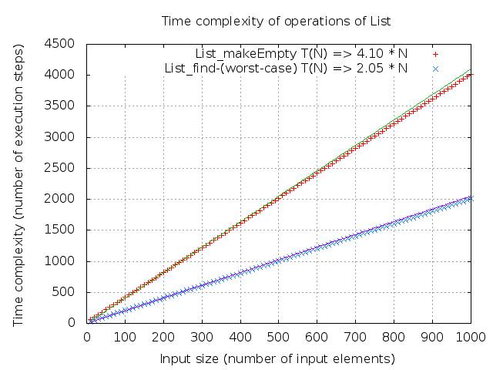

deleteList takes linear time
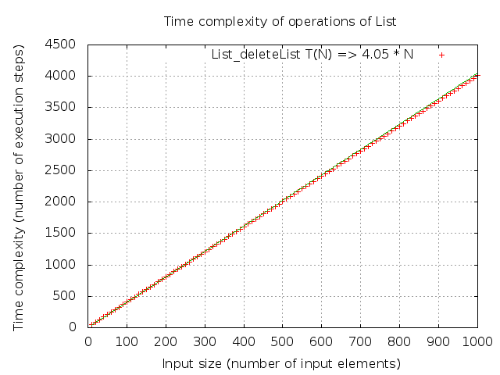

Discussion

Conclusions about the feasibility of the library, refer to the results above

Learning outcome

Improvement options
    - Improve the analysis
    - Test 1-2 more data structures, preferrably Hash Table and/or Priority Queue
    - Improve the feasibility of the library.

Time consumption
80 – 120 hours in total are reserved for this project.

Week | Duration | Hours | Phase | Content
Defining Part
9 | 28.02 – 04.03 | 9.71 | Defining | Read the requirements, found a library to evaluate, investigated some measurement methods, wrote this report
Solution Part
10 | 07.03 – 13.03 | 10 | Finding test method | Find solutions to test time/memory use, verify the solutions with one data structure
11 | 14.03 – 20.03 | 10 | Creating library | Modify the source code, create the library containing basic data structures
12 | 21.03 – 27.03 | 10 | Running test | Write all tests and run them
13 | 28.03 – 03.04 | 40 | Analysis | Analyze the test results, modify test code if needed
14 | 04.04 – 10.04 | 10 | Report | Write the report
Final Version
15 - 19 | 11.04 – 10.05 | 20 | Final | Improve according to feedback
Total |  | 118.71

Work and time consumption log:
28.02 21:00 – 23:59 2 hours Read the assignment requirements
03.02 18:00 – 22:15 4.25 hours Evaluate libraries, investigate on measurement methods
04.03 17:32 – 19:45 2.21 hours Write defining part report
04.03 20:20 – 21:35 1.25 hours Finalize report and submit

22.03 11:00 – 13:30 2.5 hours Refactore library
18:00 – 23:30 5.5 hours Methods of measurement

References
link to source code on github.com, attachments

